**Task 1:**

**Create a repository in git hub**

**Task 2:**

**Add a file to your repo using GUI**

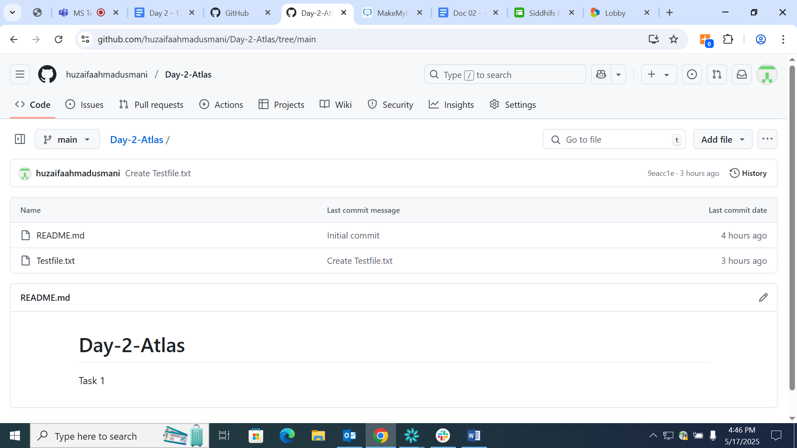

**Task 3:**

**Create a folder in your vm and create a test file 1 and 2 and try to push file1 to the repo**

**(use git commands)**

